Grant Bossa

Dr. Tammy Robertson Callahan Ph.D.

COSC 1350 NT

December 11, 2024

**Course Reflection Essay**

## **Introduction**

I have been asked to describe five things that I have learned in this class. I have learned more than five things during this class, so it is hard to pick out the five top things. However, this is not insurmountable, most of the things that I've learned that I'm mentioning in this paper are things that I can use to get a better job or using for work or personal projects that I would like to be able to have programmed for myself.

## **1st Topic**

In this class, I was introduced to Visual Studio. I have used a similar IDE before but am impressed with the advancements that this version has over the previous ones. This is easier to code with and not have to buy a separate IDE for each language that is being programmed for. I remember when you had Visual C, Visual Basic, and Java was being introduced. Each language needed its own space and software to program in. Linux and Unix still do to an extent but with virtual desktops, that difference is closing as well.

My main reason for having this as my first topic is that I can see using it to build future programs for income & personal projects.

## **2nd Topic**

Thanks to this class, I was introduced to GitHub usage for development. Being able to tie in a primary file on my system and a system on the network is nice enough by itself. This is good for both version control and being able to edit a file on the go while not in touch with my laptop. There are times when I am working on location and may not have internet or have internet but do not have my system. I can make changes either way and if nothing else, have a place to store a brainstorm file for changes that need to be made or considered.

This functionality is why it is second on my list of most important things learned in this class.

## **3rd Topic**

This next topic is something that I have heard about for years but have not had a particularly good understanding of until this class. That is CSS usage explained. Thank you for that!

I like the usage that we had with the personal page and adding more forms and pages to the original but being able to have a centralized location for formatting and being able to change an entire webpage by modifying a single file is really smart.

I have looked at a few assorted styles and have not had to deal with CSS much in my work experience. Most of that already had a format that was being used and it was just as simple to copy and paste the formatting to get the forms to work. The ability to modify a forms format separately while maintaining a central location is a boon to any future webpages or web work that I will be involved in the future.

## **4th Topic**

Along with the CSS, I have begun to learn where JavaScript can enhance a webpage or HTML page by its inclusion. It is easy to use and implement, while maintaining a separate place for code instead of having to search each HTML document for changes involving that page. In addition, having a central location / file makes it easier to manage and modify.

I am sure that there are programmers out there that want to combine code with their HTML page, and they can continue to do that. I have had to debug spaghetti code. I liken combined files to just that. Easy to find in a small, 3-to-5-page system, but I am guessing that in production, there are many more pages that will be necessary and having to search each one to find how they relate to each other is just asking for Prego, Extra Chunky.

## **5th Topic**

The last thing that makes it into the top five for this class, is the Breakout game processing. It was easier than I would have thought to build and modify. I still want to improve the class version for granddaughters. They loved being able to play it while they were here. Shown below is Brooklyn before watching me change the level to “Brooklyn’s Level.” She is seven in January and loved seeing the code next to the screen. We changed the size and speed of the ball and decided to incorporate the changes per level. She died after getting to level 3. She needed a pause button as her parents kept calling her after she got to level 2. She was also frustrated every time she got to level three, she had to go. Seeing her smile is enough to elevate this to the top.

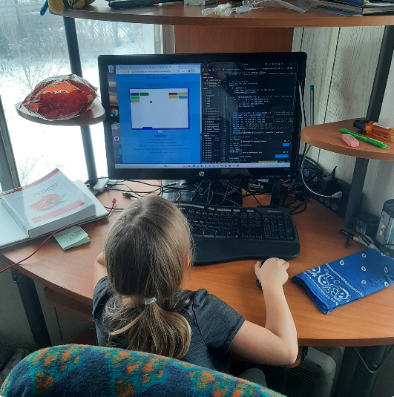

## **Conclusion**

Everything considered, I learned a lot in this class and am glad that we worked out some of the bugs and hopefully can continue learning more in the upcoming semesters. I appreciate the time it takes to get all the projects together and still have time to grade them and answer all the questions that inevitably are asked over and over. Thank you so much for your instruction and I will see more of you next semester.